Name: Period Example of a sketch

Time To Sketch…
A sketch is a rapidly executed freehand drawing that is not intended as a finished work.

Task: You will need to sketch out one uppercase and lowercase letter for each typeface category. Use your typestyle worksheets. This will leave you with a total of 7 uppercase and lowercase letter sketches.

Required
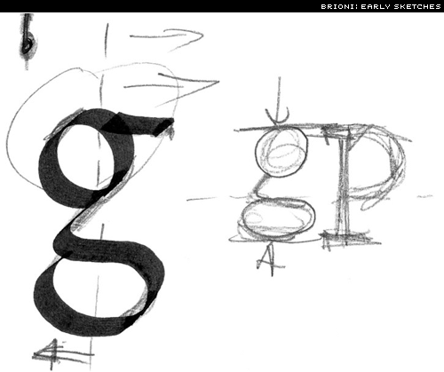
• Your letters are to conform to the rules of the specific typeface you are drawing.
• Label and mark each sketch with: Cap Height, X-height, Base Line and Beard line and type classification.

Typeface Category Classifications:
Serif: Oldstyle, Modern, Slab Serif
Sans Serif
Script, Decorative, Black Letter

Complete on graph paper, drawing paper or your own paper.
Extra credit: Do more than 7 uppercase and lowercase letter sketches and receive extra points for each extra sketch.

